**LILAVATIBAIPODAR HIGH SCHOOL**

**SEMESTER- 2 PRACTICE PAPER -2**

**BIOLOGY**

**SECTION A**

*(Attempt all questions)*

**Question1**

(i) Name the following by choosing the correct answers to the questions from the given options.

[10]

(i) The component of blood responsible for transporting oxygen is:

1. RBC
2. WBC
3. Platelets
4. Bone marrow

(ii) In humans, two cerebral hemispheres are connected by:

1. Corpus luteum
2. Hypothalamus
3. Pons varoli
4. Corpus callosum

(iii) Human eyeball consists of three layers and it encloses:

1. Lens, iris,optic nerve
2. Cornea,lens,iris
3. Lens, aqueous humour, vitreous humour
4. Cornea,lens,optic nerve

(iv) Junction of two neurons is called:

1. Joint
2. Synapsis
3. Synaptic button
4. Synapse

(v) The structural and functional unit of kidney is:

1. Renal medulla
2. Nephridia
3. Nephron
4. Urinary bladder

(vi) Which blood vessel takes blood away from the kidney:

1. Renal vein
2. Renal portal vein
3. Efferent arteriole
4. Afferent arteriole

(vii) The largest region of brain is:

1. Cerebellum
2. Cerebrum
3. Medulla
4. Pons

(viii) Hormones are distributed in the body from their place of origin through:

1. Duct
2. Blood
3. Cytoplasm
4. Bile

(ix) The part of brain that controls body temperature is:

1. Cerebrum
2. Thalamus
3. Hypothalamus
4. Pons

(x) Organ of corti is present in:

1. External ear
2. Middle year
3. Semicircular canals
4. Cochlea

**SECTION B**

*(Attempt any Three questions from this Section)*

**Question 2**

(i) What disorders are caused due to under secretion and over secretion of thyroid hormones? [2]

(ii) Give the location of lymph. What is its function? [2]

(iii) The figures given are the Cross sections of blood vessels. Label the parts 1,2and 3. [3]

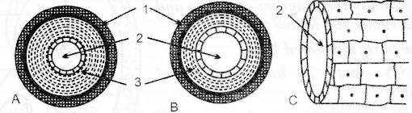

(iv) Give one function each of - cochlea, Eustachian tube and ear ossicles. [3]

**Question 3**

(i) Mention two structural differences between RBC and WBC. [2]

(ii) Where is tricuspid valve located? What is its function? [2]

(iii) Draw a neat and well labelled diagram of membranous labyrinth. [3]

(iv) Define micturition. Name the processes of urine formation. [3]

**Question 4**

(i) Explain double circulation. Name the two chambers of the mammalian heart. [2]

(ii) Give the exact location of Thyroid gland. Name a hormone produced by it. [2]

(iii) Mention one function each of the following hormones:

1. Insulin 2. Oxytocin 3. Vasopressin [3]

**Question 5**

(i) Give reasons: A person walks unsteadily when drunk. [2]

(ii) Explain power of accommodation of the eye. [2]

(iii) Given below is the diagram of the Vertical section of the human eye. Observe the diagram carefully and answer the questions that follow: [3]

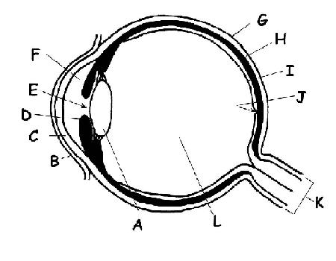

(a) Label parts E,J,L and D.

(b) Name the photosensitive pigment present in the cone cells of the retina.

(iv) Define tropic hormones. Name any two hormones secreted by posterior Pituitary gland? [3]

**Question 6**

(i) Name the part of ear responsible for: [2]

1. Static equilibrium
2. Dynamic equilibrium

(ii) Give the full form of the following abbreviations: [2]

1. FSH
2. ACTH

(iii) Give technical names of the bones present in the ear ossicles. [3]

(iv) Complete the given table by filling blanks 1 to 3.: [3]

|  |  |  |
| --- | --- | --- |
| **Gland** | **Hormone secreted** | **Effect of under secretion** |
| Adrenal | Cortical hormones | 1—-------- |
| Posterior pituitary | 2.----------- | Diabetes insipidus |
| Anterior Pituitary | Growth hormone | 3.------- |